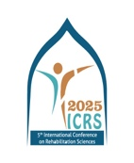**5th International Conference on Rehabilitation Sciences (ICRS 2025)**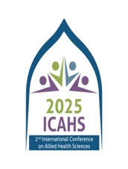

**2nd International Conference on Allied Health Sciences (ICAHS 2025)**

**October 3-5, 2025**

**ABSTRACT SUBMISSION TEMPLATE**

**Submit Abstract at** [icrs.icrahs@riphah.edu.pk](mailto:icrs.icrahs@riphah.edu.pk)

**Author(s): Underline the presenting author name.**

|  |
| --- |
|  |

**Affiliation(s)**

|  |
| --- |
|  |

* Include all relevant affiliations and number according to authors.

**Affiliations should NOT be referred to by acronyms but must be spelt out.**

**Email address/Contact/Mobile #**

|  |
| --- |
|  |
|  |

**Presentation Category/please tick**

Oral Poster Plenary Invited **\***

|  |
| --- |
| **Oral and poster** |

**Indicate the theme that best suits your research\***

* Neuro Rehabilitation
* Manual Therapy
* Pediatric Physical Therapy
* Cardiopulmonary Physical Therapy
* Sports Physical Therapy
* Women Health
* Speech Language Pathology/Therapy
* Prosthetics & Orthotics
* Audiology
* Medical Laboratory Technology
* Human Nutrition & Dietetics
* Medical Imaging Technology
* Optometry & Orthoptics
* Food Science & Technology
* Operation Theater Technology
* Others (Please Specify)

|  |
| --- |
|  |

**Abstract Title:**

|  |
| --- |
|  |

* Use sentence case, i.e. capital letter on 1st word and any proper nouns only.

**Abstract description:**

|  |
| --- |
|  |

* Maximum 200 words.

Bottom of Form