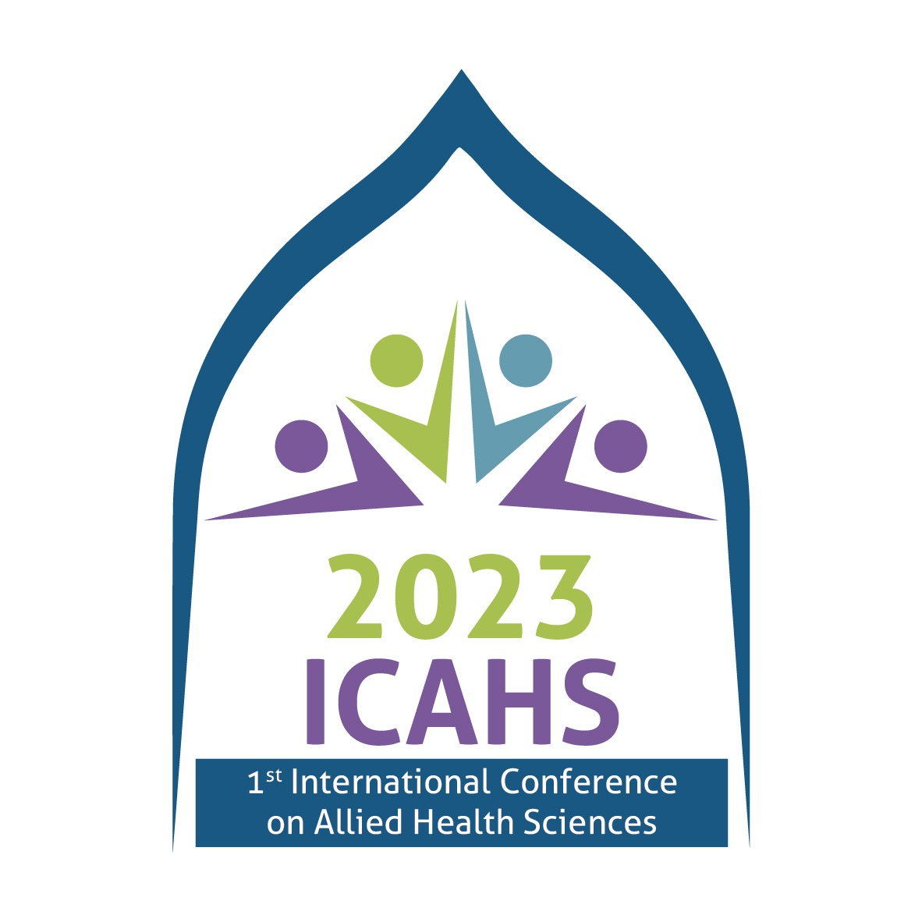
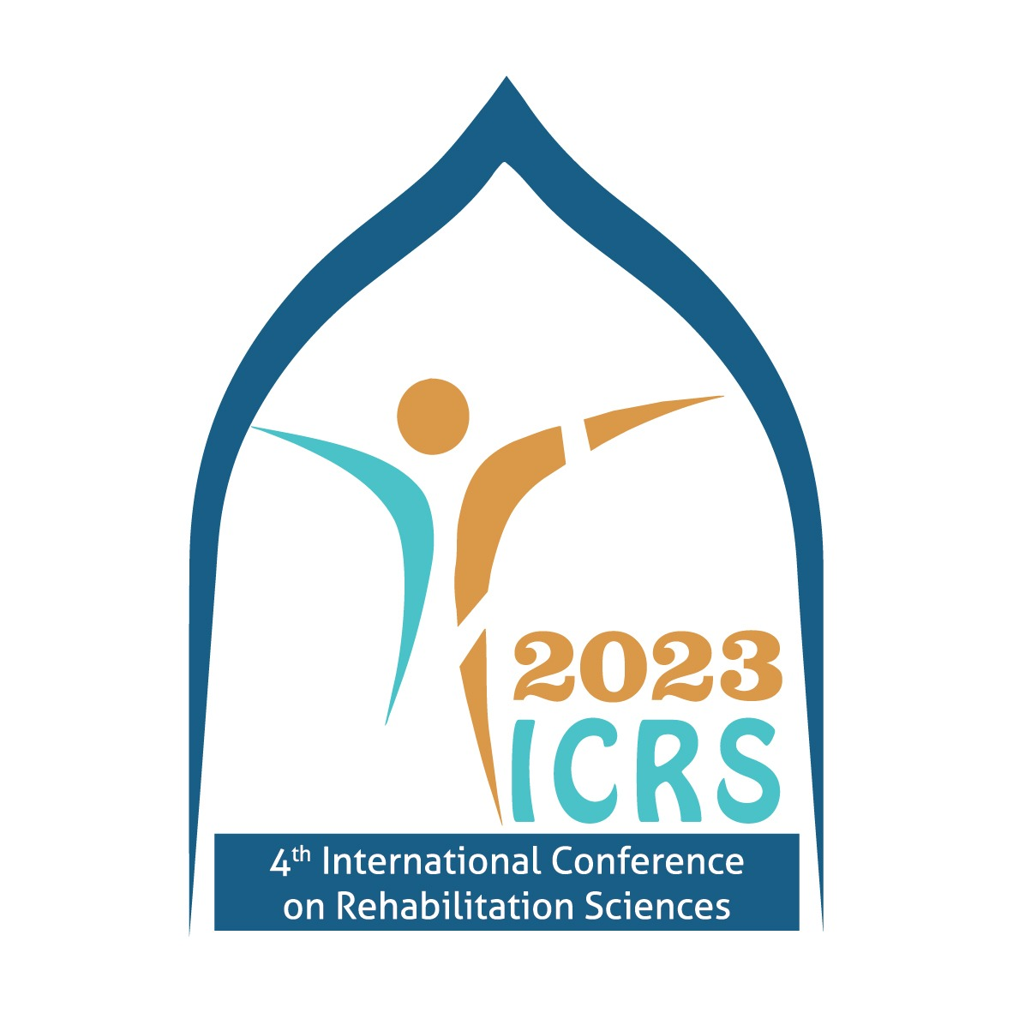
4th International Conference on Rehabilitation Sciences (ICRS 2023)

1st International Conference on Allied Health Sciences (ICAHS 2023)

October 6-8, 2023

Abstract Submission Template
Submit your Abstract at icrs23@riphah.edu.pk

Author(s): Underline the presenting author name.

Affiliation(s)
- Include all relevant affiliations and number according to author.

Affiliations should NOT be referred to by acronyms but must be spelt out.

Email address

Presentation Category

Oral Poster Plenary Invited *

Indicate the theme that best suits your research*

- Neuro Rehabilitation
- Manual Therapy
- Pediatric Physical Therapy
- Cardiopulmonary Physical Therapy
- Sports Physical Therapy
- Women Health
- Speech Language Pathology/Therapy
- Prosthetics & Orthotics
- Audiology
- Medical Laboratory Technology
- Human Nutrition & Dietetics
- Medical Imaging Technology
- Optometry & Orthoptics
- Food Science & Technology
- Others (Please Specify)

Abstract title
- Use sentence case, i.e. capital letter on 1st word and any proper nouns only.

Abstract description

Background

Purpose of study

Methodology

Results

Conclusion

Keywords

- Maximum 200 words.

